First name: | Milada | 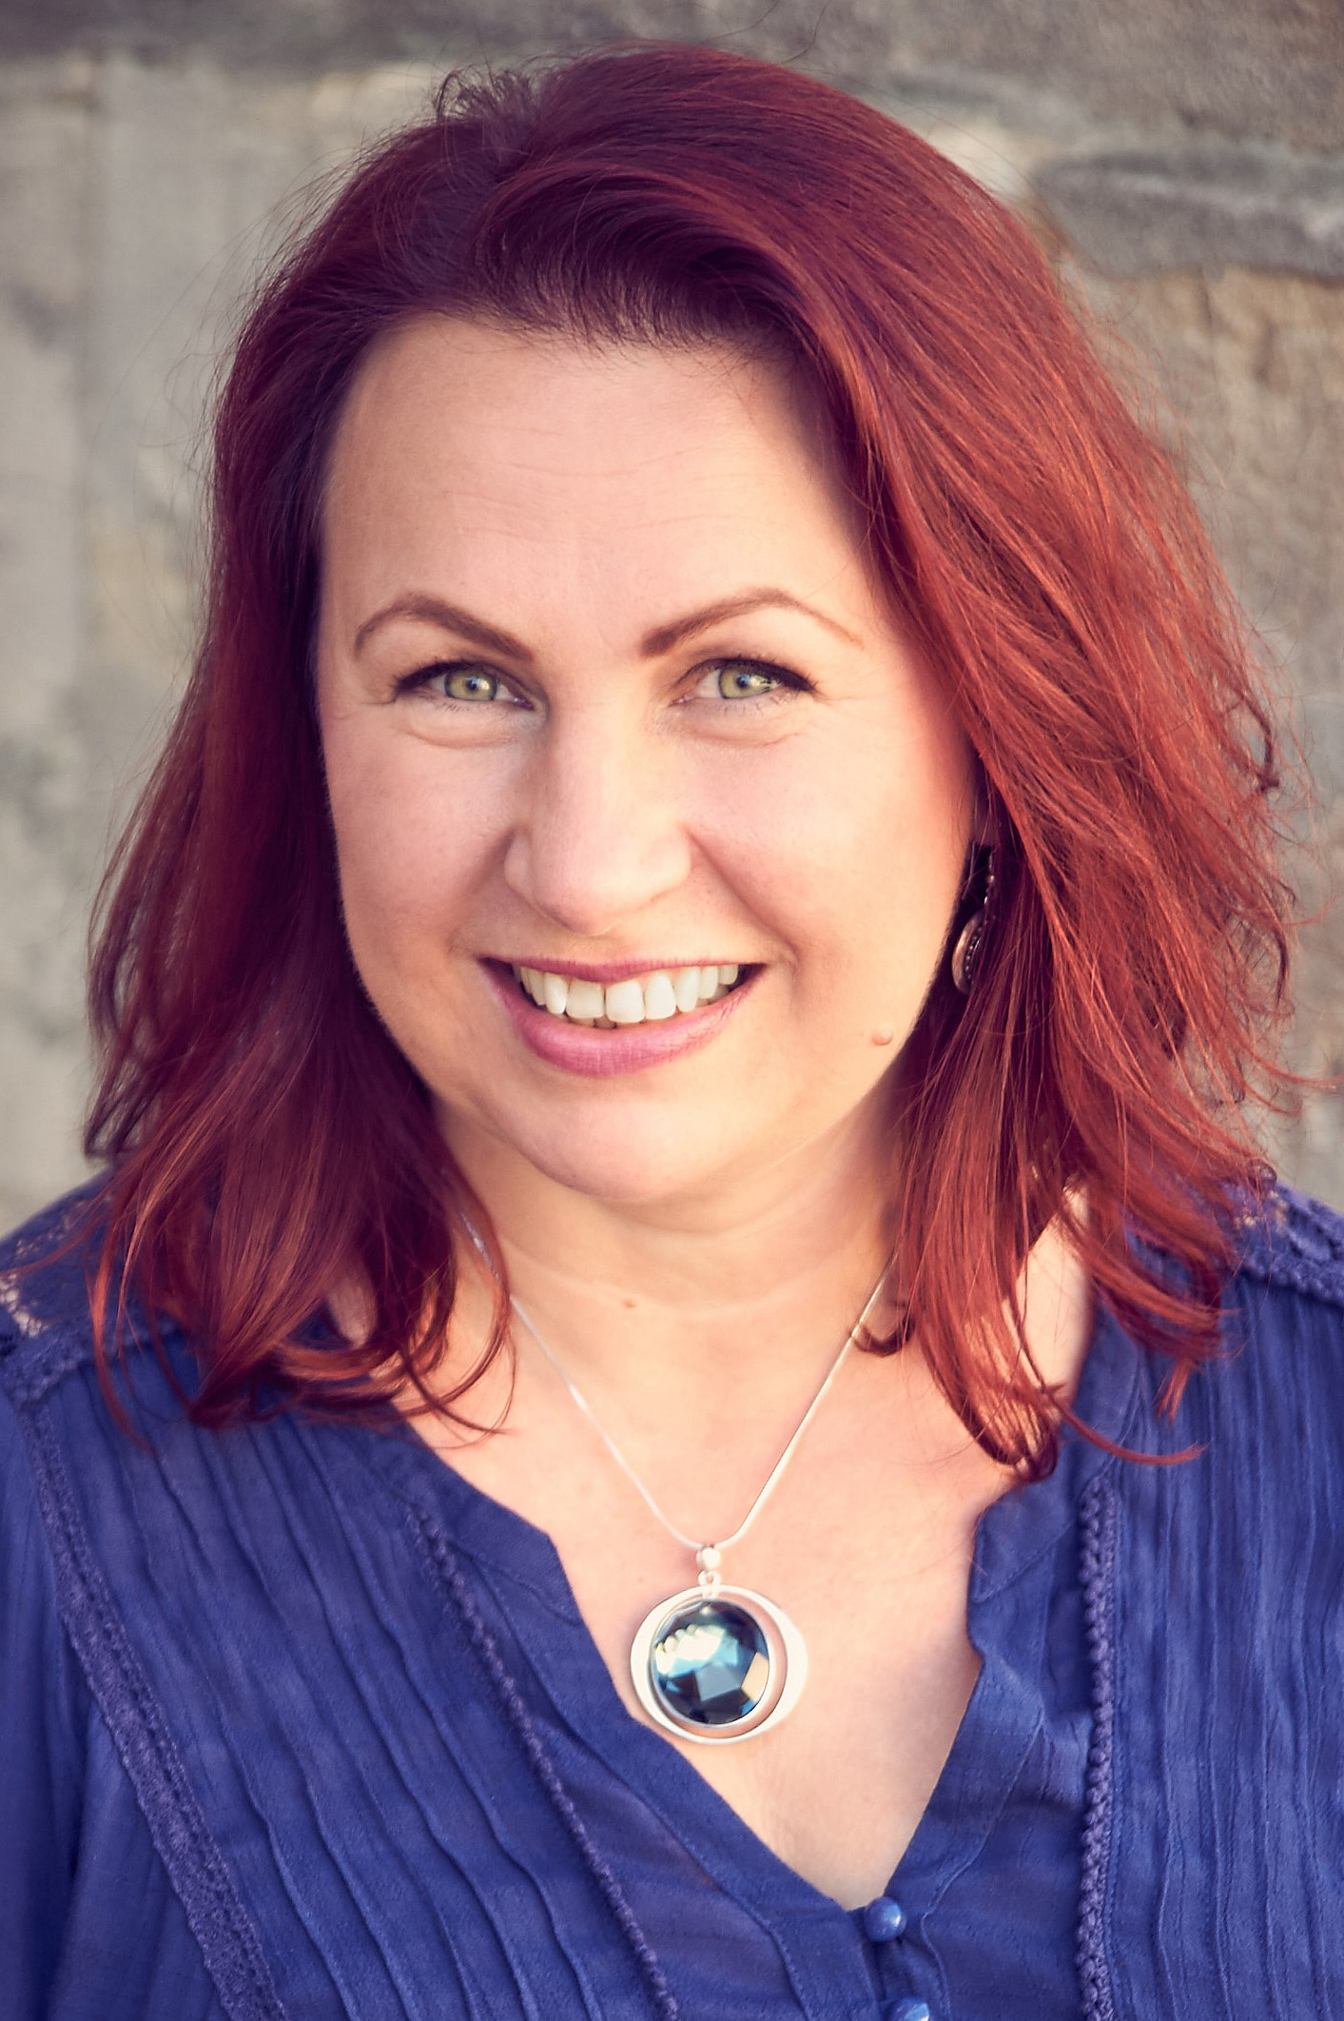  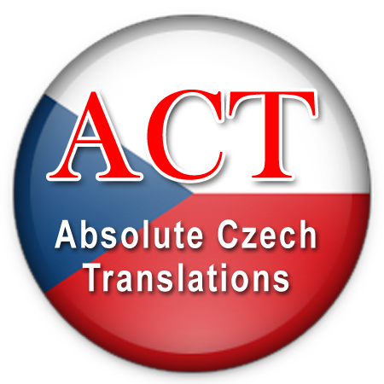  
Surname: | Cogginsová Zajíčková
Job title: | Cech freelance linguist
Trading name | Absolute Czech Translations  (Established in 2001)
Address | 60 Nobles Close, Grove, Wantage,  Oxfordshire, OX12 0NR, UK
Tel: | +44 (0)1235 770 427
Mobile: | +44 (0)7789 060 482
Email: | milada.cz@absoluteczechtranslations.co.uk
Web site: | www.absoluteczechtranslations.co.uk
Professional membership: | Institute of Translation and Interpreting MITI Qualified Member Translator/Interpreter  National Register of Public Service Interpreters NRPSI– Interim membership
Country of origin: | Czech Republic (Former Czechoslovakia)
Nationality:  Resident in the UK: | Czech  Since 1997
Milada was born in 1975 and grew up in the former Czechoslovakia. After completing her secondary hotel management school in 1993 she worked in various occupations in restaurants, a sweet shop and a haulage company. She also studied English and German. In 1997 Milada moved to the UK to study English and achieved various qualifications. In 2001 she set up her own business as a freelance translator and interpreter t/a Absolute Czech Translations. Her clients are private individuals, commercial firms, public service organisations and translation agencies. She also worked for two English law firms as a legal secretary. Milada is a film and theatre enthusiast and studied creative writing for performance at Ruskin College in Oxford. Her hobbies are music, film, theatre and creative writing.
LANGUAGE SKILLS
Mother tongue: | Czech (native speaker)
Habitual use: | English (understanding of the English culture; extensive vocabulary)
Passive language: | Slovak (excellent understanding of spoken and written Slovak)

PROFESSIONAL SKILLS
- Translation from English into Czech; Czech into English; Slovak into English
- Proofreading of translations (English into Czech and Czech into English)
- Translating and checking sub-titles
- Web site localisation, SEO and writing web site content in Czech and English
- Copywriting in Czech and English
- Voice-Over recordings
- Consecutive Interpreting Czech – English; Slovak – English (Ad-hoc, telephone, Skype)
- Simultaneous Conference Interpreting from English into Czech and Czech into English
- Transcription of audio recordings (fast and accurate audio-typing)
- Creative writing (short stories, stage plays, radio plays, film scripts, adaptations, poetry, song lyrics)

IT AND SOFTWARE EQUIPMENT:  - SDL Trados Studio 2019 translation memory software  - User of SDL Premium Technical Support  - MICROSOFT Windows 10 and Office 365  - Final draft (script writing software) | 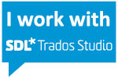
OTHER
- Clean driving licence and own car

WORK EXPERIENCE
- Freelance linguist t/a Absolute Czech Translations since 2001
- Legal secretary – employment law, Manches Solicitors LLP: Oxford 2003/4
- Admin assistant – customer services department at global investment management company Invesco Perpetual, Henley on Thames 2002/3
- Legal secretary – probate and tax planning, Mercers Solicitors, Henley-on-Thames 2001/2
- Administrative assistant – Road haulage company, Czech Republic 1996
- Various work in the catering and hotel industry in the Czech Republic, UK and Austria

INTERESTS
Music, Film, TV programmes, Theatre, Creative writing, Songwriting
EDUCATION, QUALIFICATIONS, CPD COURSES
Course / Qualification / CPD workshop | Level | School/Accreditation | Month/Year
Introduction to subtitling | 1-day workshop | University of Westminster | Nov. 2016
Creative writing for performance  (film scripts, stage plays, radio plays, dramatic monologues, comedy, poetry, adaptations, copyright law) | Certificate of higher education  (Merit) | Ruskin College, Oxford  The Open University | 2013 - 2016
SDL Trados Studio 2015 | Advanced 1-day c. | Lingvajet / SDL | Dec. 2015
SDL Trados Studio 2014 | Intermediate 1-day c. | Lingvajet / SDL | Feb. 2015
Singer’s workshop;  Composition vocal;  Learn to sing the Bel Canto; Scriptwriting | Evening courses  10 weeks each | Oxford University Continuing Education | 2012-2013
Neurolinguistic Programming | Master practitioner | New Oceans / INLPTA | 2009 - 2011
Simultaneous conference interpreting | 2-day crash course | University of Leeds | Feb 2008
Voice-over training by Daniel Pageon | 1-day course | Actor’s World Production/ITI | March 2007
SDL Trados Translator’s Workbench | Intermediate | SDL Slough | Nov. 2006
Teaching Adult Learners Certificate | Stage I. | Cherwell Coll. Oxford C&G | 2003 - 2004
Diploma in Public Service Interpreting – Law Eng/Cze | DPSI is equivalent to  1st Degree VQ level 6 | Institute of Linguists (IoL)  OFQUAL | July 2002
Diploma in Translation Eng/Cze | DipTrans Part I and II | Institute of Linguists (IoL) | Sept. 2001
Para-legal Training – Modules:  The Legal Environment, General Legal Principles, Retail & Consumer Matters, European Law | Vocational legal studies - level II  (Distinction) | Institute of Legal Executives | June 1999
English Language and Literature,  History, Sociology, Business Studies | A-levels | Henley College / AQA | 1998 - 2000
Proficiency in Cambridge English | English as foreign lang. | Univ. of Cambridge | June 1999
English for business and tourism | Level II. | Henley College / LCCIEB | 1997 - 1998
First certificate in English;  Advanced Cambridge English | English as foreign lang. | University of Cambridge, International examinations | 1997
English as foreign language | 1-year lang. school | Corfix, Brno, CR | 1995 - 1996
Czech language and literature, Russian, German, Economics and Accountancy, Catering and hotel management | 4-years full time secondary education completed by A-levels | Hotel Management School, Velké Meziříčí, CR | 1989 - 1993

SUBJECTS OF KNOWLEDGE AND EXPERIENCE

Types of documents and texts translated in the past
- Business contracts, Terms and conditions, documentation related to accounting and tax
- Education qualifications certificates
- Legal documents, correspondence, court decisions, crime investigation - expert witness reports (pathology, paediatrics, psychology, surgery, technology, etc.)
- Market research questionnaires, online surveys
- Official and legal documents (registered translator with the Czech Consulate in London)
- Training courses, tutorials
- TV programme synopsis and highlights (Discovery and ID Xtra, previously also National Geographics on a monthly basis since 1997), voice-over scripts and narratives
- User guides and products descriptions, data sheets, packaging labels, technical manuals
- Websites and marketing materials
Work experience at English law firms. Familiar with the areas of law: family, employment, criminal, contract, intellectual property, probate, traffic.
Subjects

Aerospace
Advertising
Agriculture
Animal feeds
Art
Automotive
Business
Clothes and shoes retail
Construction industry
Cosmetics
Cleaning products
Education and training
Electronics
Emissions trading
Engineering
Environment
Film production
Financial
Food and drink
Government / EU
Health and Safety
Health care, dentistry
Insurance
Interior design
IT
Law
Manufacturing
Marketing
Market research
Medicine/pharmaceutical
Power engineering
Social care
Software
Technical
Telecoms
Transport

INTERPRETING
Consecutive Interpreting Czech – English; Slovak – English
- At face to face meetings, training sessions, during court hearings or police interviews
- Over the telephone and Skype

Simultaneous Interpreting from English into Czech and from Czech into English
- Experience of simultaneous interpreting in conference settings using an audio sound booth, attended a crash course in conference interpreting at the University of Leeds in 2008.
- Via internet platforms (presentations, training courses, select group meetings)
- Extensive knowledge of vocabulary on many subjects in English and Czech and ability to interpret simultaneously to a very good standard.
- Simultaneous whispered interpreting during court hearings and business meetings.
- Simultaneous interpreting of press interviews with sportsmen during press conferences

Examples of previous types of clients and topics of interpreting
- Public service organisations in the UK (Courts, Police, HM Prison Service, Inland Revenue, Benefits Office, Housing Associations, Social services, Education authorities, etc.)
- Health care providers (GP surgeries, hospitals, dentists, maternity units, consultants)
- Interpreting for solicitors, barristers and their Czech or Slovak speaking clients
DPSI - Law qualified interpreter and since 2001 have done over 1500 hours of public service interpreting for Language Line. Knowledge of the English legal system.
- Government officials (Interpreting for Czech senators during their 3-day visit in the UK (meetings in the House of Lords, Ministry of Transport, DEFRA and the Royal Agricultural College in Cirencester)
- Business negotiations between manufacturers and importers discussing the terms and conditions of business representation and dealership of products (at face to face meetings and over the telephone)
- Negotiation between a Czech manufacturer and UK energy supplier regarding supplies of containers and packaging for storage and transport of dangerous substances
- Negotiation of potential co-operation of a Czech training business with UK training org. and universities
- Staff training courses including health and safety training at construction sites
- Interpreting for a film editor, music composer and film director at a film post production
- Telephone interpreting for Peugeot helpdesk (3 years) technical problem solving
Translating, proofreading and checking of subtitles, film narratives and scripts
Translated subtitles for TV documentary programs, narratives of animated films, checked subtitles for the feature film “The Prince of Persia”, translated and proofread scripts and narratives of corporate training videos and online tutorials for voiceover recordings.
Researching, extracting information and writing summaries
Summaries, extracts and translations of the key points from lengthy documents
Example: Extracts from reports regarding safe running of a nuclear power plant in Slovakia
Web site localisation and writing web site content in Czech and English
Translated and written the content for several web sites. Good knowledge of online marketing, search engine optimisation and the best use of keywords within the web site content.
Copywriting in Czech and English
Brochures, leaflets, advertising slogans, business correspondence, email newsletters, articles for newspapers and also training course materials in both Czech and English.
Voice-over recordings – in Czech and in English with a typical East-European accent
Experience of performing voice-over recordings in professional recording studios. Recorded voices of characters on corporate training videos, software instructions, toys adverts.
Able to demonstrate good pronunciation, accurate reading and voice projection in a variety of voices. Able to provide short recording samples of scripts for your new projects.
Transcription of audio recordings
Police interviews, Business meetings, Corporate films, YouTube tutorials, Documentary films

