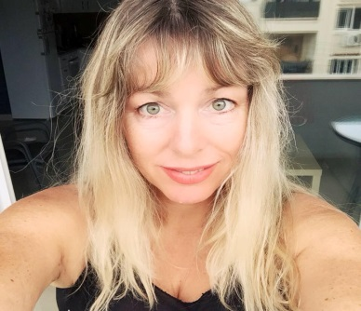

|  |  |
| --- | --- |
| PERSONAL INFORMATION | Sharron C T Connor |
|  | |
|  | 42E, Arch. Makarios III Avenue, Matina Building, 3rd Floor, Office 303, 1065 Nicosia, Cyprus |
| +357 22 321056  +357 99 895649 |
| info@futuresquetranslations.com |
| Sex Female | Date of birth 24/02/1967 | Nationality British |

|  |  |
| --- | --- |
| LANGUAGE COMBINATIONS | Greek into English |
| TRANSLATION EXPERIENCE | 30 years |

|  |  |
| --- | --- |
| WORK EXPERIENCE |  |

|  |  |
| --- | --- |
| **(2015-present)** | **Executive Corporate Administrator/Translator** |
| **Excellenzia Corporate Services Ltd**  42E, Arch. Makarios Avenue, Matina Building, 3rd Floor, Office 303, 1065 Nicosia, Cypruswww.registercypruscompany.com |
| * Day-to-day running of the business (registering and maintaining companies), client liaison,marketing, translations |
| **Business or sector** Provider of corporate, fiduciary and translation services |
| **(2009-2015)** | **Managing Director/Translator** |
|  | **Transinc Global Services Ltd**  2, Ayios Pavlos & Kadmos Street, Wisdom Tower, 3rd Floor, 1105 Nicosia, Cyprus |
|  | * I created this company myself from scratch. Day-to-day running of the business (registering and maintaining companies), client liaison, marketing, translations |
|  | **Business or sector** Provider of corporate, fiduciary and translation services |
| **(2000-present)** | **Holiday Rentals Manager** |
|  |
| * In charge of running our small family business involving the rental of 5 properties (that I actually created myself from scratch) specialising in holiday rentals in Protaras and Nicosia |
| **Business or sector** Rental of holiday properties |
|  |  |
| **(1990-present)**    **(1989-1990)** | **Freelance Translator** |
| Freelance translator specialising in Greek and English commercial, legal, medical and financial translations |
| **Business or sector** Translations   |  |  |  |  |  | | --- | --- | --- | --- | --- | | **Translation Project Manager**   |  | | --- | | **Aget Language Services Ltd**  Harrow, London | | Project manager/ translator, arranging translations for corporate clients from and into various languages, translating texts myself as well | | **Business or sector** Translations | |  | |  | |  | |  | |

|  |  |
| --- | --- |
| EDUCATION AND TRAINING |  |

|  |  |  |
| --- | --- | --- |
| (1985-1989)  (1990-present) | BA (Hons.) Applied Language Studies (2i) |  |
| Ealing College of Higher Education, West London, UK | |
| Fully qualified member (MITI) of the Institute of Translation & Interpreting (ITI), United Kingdom (membership number: 5097)  Regular Member of the Pancyprian Union of Graduate Translators and Interpreters (PANUTI), Cyprus (membership number: 093)   Member of the International Federation of Translators/Interpreters/Terminologists FIT/IFT | |

|  |  |
| --- | --- |
| LANGUAGE SKILLS |  |

|  |  |  |  |  |  |
| --- | --- | --- | --- | --- | --- |
| Mother tongue(s) | English | | | | |
|  |  | | | | |
| Other language(s) | UNDERSTANDING | | SPEAKING | | WRITING |
| Listening | Reading | Spoken interaction | Spoken production |  |
| Greek | C1/2 | C1/2 | C1/2 | C1/2 | B1/2 |
|  |  | | | | |
|  | Levels: A1/2: Basic user - B1/2: Independent user - C1/2 Proficient user  Common European Framework of Reference for Languages | | | | |

|  |  |
| --- | --- |
|  | w |
| TRANSLATION SOFTWARE |  |

|  |  |
| --- | --- |
|  | **SDL TRADOS STUDIO 2019** |