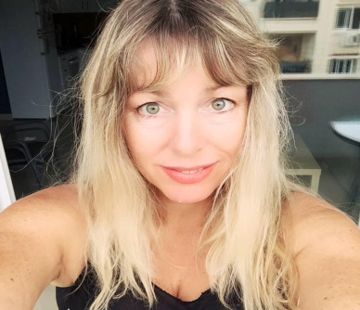

PERSONAL INFORMATION | Sharron C T Connor
 | 42E, Arch. Makarios III Avenue, Matina Building, 3rd Floor, Office 303, 1065 Nicosia, Cyprus
 | +357 22 321056 +357 99 895649
 | info@futuresquetranslations.com
 | Sex Female | Date of birth 24/02/1967 | Nationality British
LANGUAGE COMBINATIONS | Greek into English
TRANSLATION EXPERIENCE | 30 years

WORK EXPERIENCE

(2015-present) | Executive Corporate Administrator/Translator
(2015-present) | Excellenzia Corporate Services Ltd  42E, Arch. Makarios Avenue, Matina Building, 3rd Floor, Office 303, 1065 Nicosia, Cyprus www.registercypruscompany.com
(2015-present) | - Day-to-day running of the business (registering and maintaining companies), client liaison, marketing, translations
(2015-present) | Business or sector Provider of corporate, fiduciary and translation services
(2009-2015) | Managing Director/Translator
Transinc Global Services Ltd
2, Ayios Pavlos & Kadmos Street, Wisdom Tower, 3rd Floor, 1105 Nicosia, Cyprus
 | - I created this company myself from scratch. Day-to-day running of the business (registering and maintaining companies), client liaison, marketing, translations
 | Business or sector Provider of corporate, fiduciary and translation services
(2000-present) | Holiday Rentals Manager
(2000-present) | - In charge of running our small family business involving the rental of 5 properties (that I actually created myself from scratch) specialising in holiday rentals in Protaras and Nicosia
(2000-present) | Business or sector Rental of holiday properties
(1990-present)  (1989-1990) | Freelance Translator
(1990-present)  (1989-1990) | Freelance translator specialising in Greek and English commercial, legal, medical and financial translations
(1990-present)  (1989-1990) | Business or sector Translations
  Translation Project Manager
  Aget Language Services Ltd
  Harrow, London
  Project manager/ translator, arranging translations for corporate clients from and into various languages, translating texts myself as well
  Business or sector Translations
EDUCATION AND TRAINING

(1985-1989)  (1990-present) | BA (Hons.) Applied Language Studies (2i)
(1985-1989)  (1990-present) | Ealing College of Higher Education, West London, UK
(1985-1989)  (1990-present) | Fully qualified member (MITI) of the Institute of Translation & Interpreting (ITI), United Kingdom (membership number: 5097)  Regular Member of the Pancyprian Union of Graduate Translators and Interpreters (PANUTI), Cyprus (membership number: 093)  Member of the International Federation of Translators/Interpreters/Terminologists FIT/IFT
LANGUAGE SKILLS

Mother tongue(s) | English
Other language(s) | UNDERSTANDING |  | SPEAKING |  | WRITING
Other language(s) | Listening | Reading | Spoken interaction | Spoken production
Greek | C1/2 | C1/2 | C1/2 | C1/2 | B1/2
Levels: A1/2: Basic user - B1/2: Independent user - C1/2 Proficient user
Common European Framework of Reference for Languages

w
TRANSLATION SOFTWARE

SDL TRADOS STUDIO 2019

